Title: **Vacuum Cleaner**



**Project Proposal**

**Theory Of Automata**

Submitted BY:

Javeed Ahmad

and

Syed Muhammad Faizan Bukhari

SAP ID# 21521 and 21532

Submitted to: Umme-Hani

**Department of Computer Science**

**Riphah International University**

**Lahore Campus**

**Expense Tracker**

1. **Project Introduction:**

A vacuum cleaner is a machine that sucks up dirt, dust and other small particles from floors and carpets using suction. It's used to clean houses and other places.

1. **Scope of the Project:**

The main objective of the project is to know the working of automatic vacuum cleaner.

1. **Problem statement:**

"Currently, there is a lack of understanding of the technology and mechanics behind automatic vacuum cleaners. The purpose of this project is to research and understand the working of an automatic vacuum cleaner in order to improve its functionality and usability for household cleaning tasks

1. **Sates:**

* 0n 1
* 0ff 0
* Right 2
* Left 3
* Detect Dirt 4
* Suck dirt 5
* Rotate 6
* Charge 7
* Idle State 8

1. **Regular Expression:**

1 ( ( 4(5)* ( 24 (5)* + 34 (5)* + 64 (5)* )* 8 ) + ( 01 ) + ( 8 ( 7 )+ 8 ) **)* 0**

1. **CFG:**

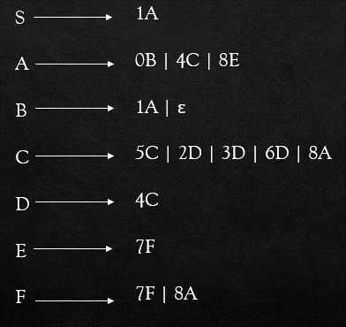

1. 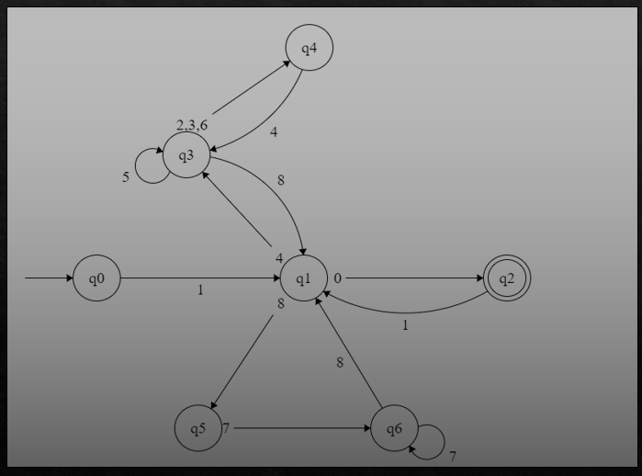**DFA:**